**【学术前沿动态】2022年诺贝尔化学奖相关论文分析**

2022年诺贝尔化学奖被授予美国化学家罗琳·贝尔托齐（Carolyn R. Bertozzi）、丹麦化学家摩顿·梅尔达尔(Morten Meldal)、美国化学家卡尔·巴里·夏普利斯(K. Barry Sharpless)，以表彰他们在“点击化学和生物正交化学”领域作出的贡献。以下对三位诺奖得主的相关主题学术论文和相关施引文献展开分析。

**一、获奖者的发文分析**

三位获奖者相关主题的SCIE论文有332篇，最早发文年限可追溯到2000年，各年度发文分布如图1所示。近10年论文中，ESI高被引论文15篇。

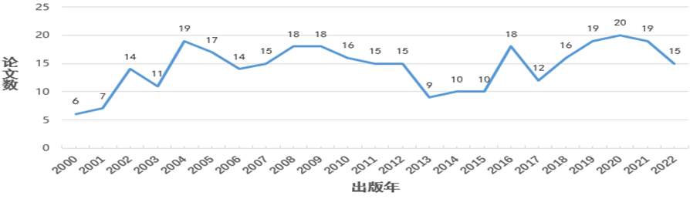

图1 诺贝尔化学奖获得者相关主题论文年度分布

获奖者相关主题论文涉及化学多学科、生物化学与分子生物学和多学科科学等领域，论文分布于109种期刊，其中40篇发表于Angewandte Chemie International Edition期刊，占所有文献12%，39篇发表于Journal of the American Chemical Society，占比12%。37篇发表在Proceedings of the National Academy of Sciences of the United States of America，占比11%。

三位获奖者的相关主题学术论文详见武汉大学图书馆化学学科服务平台：<https://libguides.lib.whu.edu.cn/c.php?g=665822&p=6765489>。

**二、相关施引文献分析**

截至2022年11月15日，三位诺贝尔化学奖得主的332篇相关文献被全球39743篇论文引用，总被引84156次，篇均被引频次为252.72；从全球来看，施引文献从2000年到2022年持续增长，2000年仅有10篇，2021年高达3252篇，如图2。全部施引文献分布在120个国家/地区，排名第一的是美国，发文量达10422篇；中国排在第二，发文量为7191篇。

结合本次诺奖的获奖原因，构造相应主题检索策略，从施引文献中筛选出与诺奖主题相关的论文共计23189篇（占全部施引文献的58%）,下面针对这部分相关施引文献从不同角度进行分析。

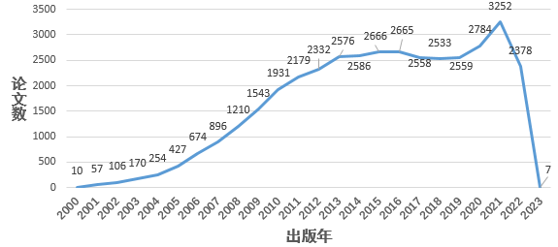

图2 相关施引文献的年度分布

23189篇相关施引文献分布于1554种期刊，如图3所示，其中Chemical Communications、Angewandte Chemie International Edition和Journal of the American Chemical Society发文占10%。TOP20期刊见图3。

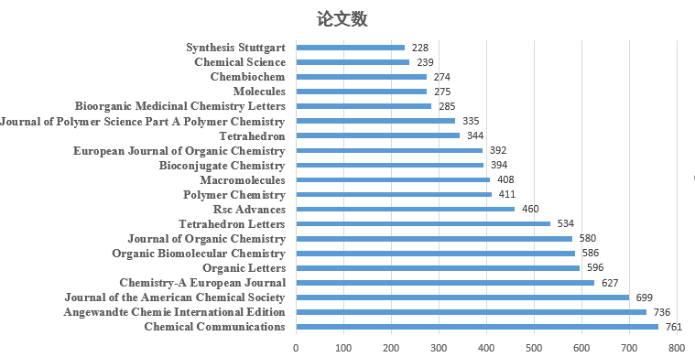 图3 相关施引文献的TOP20期刊分布

23189篇论文涉及全球111个国家/地区，其中中国作者参与的相关施引文献共计4561篇，居全球第2。涉及的TOP10机构排名如图4。

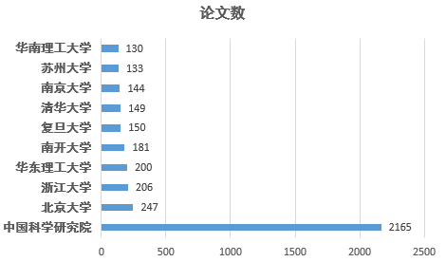

图4 相关施引文献涉及的中国TOP10机构

根据来自相关主题施引文献的关键词进行词频统计，得到高频关键词词云，出现频率最高的包括点击化学（7602次）、环加成反应（2407次）、叠氮化物（2286次）、末端炔烃（2252次）、叠氮炔环加成（1122次）、纳米颗粒（855次）、1-2-3唑（632次）、嵌段共聚物（627次）、糖基化（439次），生物正交化学（254次）等。详见图5。

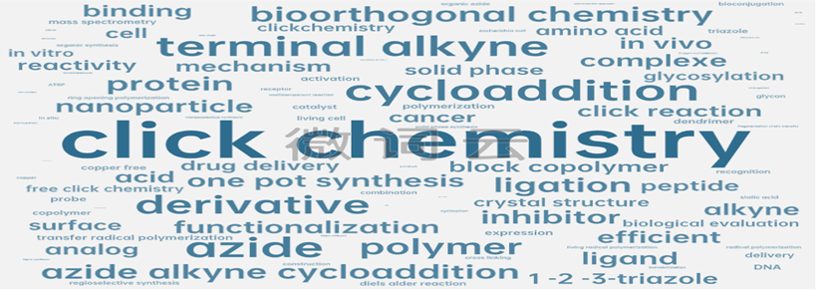

图5 全球施引文献的关键词词云图

图6为关键词共现聚类时线图，该图通过关键词共现的频次反映主题间的关系以及时间发展情况，可见2012年以来施引文献的关键词聚类主要集中在5-取代-1H-四唑、点击化学、活体细胞、唾液酸、生物评价等，详见图6。

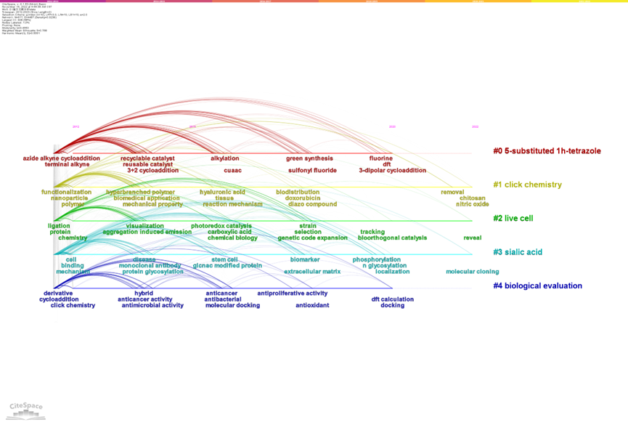

图6 2012-2022年全球施引文献的关键词聚类时线图

**三、相关主题高影响力论文**

近10年的诺贝尔获奖者相关主题学术论文中，ESI高被引论文15篇，论文信息如下，其中中国作者发文见文献[8]和[15]。

[1] AgarwaL P, Bertozzi C R. [Site-Specific Antibody-Drug Conjugates: The Nexus of Biciorthogonal Chemistry, Protein Engineering, and Drug Development](https://pubs.acs.org/doi/10.1021/bc5004982)[J]. Bioconjugate Chemistry, 2015, 26(2): 176-92.

[2] Ahn G, Banik S M, Miller C L, et al. LYTACs that Engage the Asialoglycoprotein Receptor for Targeted Protein Degradation[J]. Nature Chemical Biology, 2021, 17(9): 937-46.

[3] Banik S M, Pedram K, Wisnovsky S, et al. [Lysosome-Targeting Chimaeras for Degradation of Extracellular Proteins](https://www.nature.com/articles/s41586-020-2545-9)[J]. Nature, 2020, 584(7820): 291-297.

[4] Dong J J, Krasnova L, Finn M G, et al. [Sulfur(VI) Fluoride Exchange (SuFEx): Another Good Reaction for Click Chemistry](https://onlinelibrary.wiley.com/doi/10.1002/anie.201309399)[J]. Angewandte Chemie-International Edition, 2014, 53(36): 9430-9448.

[5] Flynn R A, Belk J A, Qi Y Y, et al. [Discovery and Functional Interrogation of SARS-CoV-2 RNA-host Protein Interactions](https://www.sciencedirect.com/science/article/pii/S009286742100297X?via%3Dihub)[J]. Cell, 2021, 184(9): 2394-2411.e16.

[6] Flynn R A, Pedram K, Malaker S A, et al. [Small RNAs are Modified with N-glycans and Displayed on the Surface of Living Cells](https://www.sciencedirect.com/science/article/pii/S0092867421005031?via%3Dihub)[J]. Cell, 2021, 184(12): 3109-3124.e22.

[7] Marschallinger J, Iram T, Zardeneta M, et al. [Lipid-droplet-accumulating Microglia Represent a Dysfunctional and Proinflammatory State in the Aging Brain](https://www.nature.com/articles/s41593-019-0566-1)[J]. Nature Neuroscience, 2020, 23(2): 194-208.

[8] Meng G Y, Guo T J, Ma T C, et al. [Modular Click Chemistry Libraries for Functional Screens Using a Diazotizing Reagent](https://www.nature.com/articles/s41586-019-1589-1)[J]. Nature, 2019, 574(7776): 86-89.

[9] Neelamegham S, Aoki-Kinoshita K, Bolton E, et al. [Updates to the Symbol Nomenclature for Glycans Guidelines](https://academic.oup.com/glycob/article/29/9/620/5513705?login=true)[J]. Glycobiology, 2019, 29(9): 620-624.

[10] Paszek M J, Dufort C C, Rossier O, et al. [The Cancer Glycocalyx Mechanically Primes Integrin-Mediated Growth and Survival](https://www.nature.com/articles/nature13535)[J]. Nature, 2014, 511(7509): 319-325.

[11] Pluvinage J V, Haney M S, Smith B A H, et al. [CD22 Blockade Restores Homeostatic Microglial Phagocytosis in Ageing Brains](https://www.nature.com/articles/s41586-019-1088-4)[J]. Nature, 2019, 568(7751): 187-192.

[12] Riley N M, Bertozzi C R, Pitteri S J. [A Pragmatic Guide to Enrichment Strategies for Mass Spectrometry-Based Glycoproteomics](https://www.sciencedirect.com/science/article/pii/S1535947620351434?via%3Dihub)[J]. Molecular & Cellular Proteomics, 2021, 20(100029):1-28.

[13] Smith B A H, Bertozzi C R. [The Clinical Impact of Gycobiology: Targeting Selectins, Siglecs and Mammalian Glycans](https://www.nature.com/articles/s41573-020-00093-1)[J]. Nature Reviews Drug Discovery, 2021, 20(3): 217-243.

[14] Theruvath J, Menard M, Smith B A H, et al. [Anti-GD2 Synergizes with CD47 Blockade to Mediate Tumor Eradication](https://www.nature.com/articles/s41591-021-01625-x)[J]. Nature Medicine, 2022, 28(2): 333-344.

[15] Zheng Q H, Xu H T, Wang H, et al. [Sulfur F-18 Fluoride Exchange Click Chemistry Enabled Ultrafast Late-Stage Radiosynthesis](https://pubs.acs.org/doi/10.1021/jacs.0c09306)[J]. Journal of the American Chemical Society, 2021, 143(10): 3753-3763.

**四、高影响力施引文献**

2020年来ESI高被引文献共14篇，论文信息如下，其中中国作者发文见文献[5]、[7]、[11]和[14]。

[1] Alamri M A, Ul Qamar M T, Mirza M U, et al. [Pharmacoinformatics and Molecular Dynamics Simulation Studies Reveal Potential Covalent and FDA-Approved Inhibitors of SARS-CoV-2 Main Protease 3CL(pro)](https://www.tandfonline.com/doi/full/10.1080/07391102.2020.1782768)[J]. Journal of Biomolecular Structure & Dynamics, 2021, 39(13): 4936-4948.

[2] BOJAR D, MECHE L, MENG G M, et al. [A Useful Guide to Lectin Binding: Machine-Learning Directed Annotation of 57 Unique Lectin Specificities](https://pubs.acs.org/doi/10.1021/acschembio.1c00689)[J]. Acs Chemical Biology, 2022, 17(11):2993–3012.

[3] Frye N L, Daniliuc C G, Studer A. [Radical 1-Fluorosulfonyl-2-alkynylation of Unactivated Alkenes](https://onlinelibrary.wiley.com/doi/10.1002/anie.202115593)[J/OL]. Angewandte Chemie-International Edition, 2022, 61(12).(2021-12-27)[2022-11-15]. https://doi.org/10.1002/anie.202115593.

[4] Haufe G. [Synthesis and Application of Pentafluorosulfanylation Reagents and Derived Aliphatic SF5-containing Building Blocks](https://www.sciencedirect.com/science/article/pii/S0040402022000333?via%3Dihub)[J/OL]. Tetrahedron, 2022, 109.(2022-3-12)[2022-11-15]. https://doi.org/10.1016/j.tet.2022.132656.

[5] Ma Z H, Liu Y A, Ma X Y, et al. [Aliphatic Sulfonyl Fluoride Synthesis via Reductive Decarboxylative Fluorosulfonylation of Aliphatic Carboxylic Acid NHPI Esters](https://pubs.rsc.org/en/content/articlelanding/2022/QO/D1QO01655E)[J]. Organic Chemistry Frontiers, 2022, 9(4): 1115-1120.

[6] Meyer T H, Samanta R C, Del Vecchio A, et al. [Mangana(iii/iv)electro-catalyzed C(sp(3))-H Azidation](https://pubs.rsc.org/en/content/articlelanding/2021/SC/D0SC05924B)[J]. Chemical Science, 2021, 12(8): 2890-2897.

[7] Niu L B, Jiang C Y, Liang Y W, et al. [Manganese-Catalyzed Oxidative Azidation of C(sp(3))-H Bonds under Electrophotocatalytic Conditions](https://pubs.acs.org/doi/10.1021/jacs.0c08437)[J]. Journal of the American Chemical Society, 2020, 142(41): 17693-17702.

[8] Rezaei-Ghaleh N, Agudo-Canalejo J, Griesinger C, et al. [Molecular Diffusivity of Click Reaction Components: The Diffusion Enhancement Question](https://pubs.acs.org/doi/10.1021/jacs.1c11754)[J]. Journal of the American Chemical Society, 2022, 144(3): 1380-1388.

[9] Rodriguez E, Boelaars K, Brown K, et al. [Sialic Acids in Pancreatic Cancer Cells Dive Tumour-associated Macrophage Differentiation via the Siglec Receptors Siglec-7 and Siglec-9](https://www.nature.com/articles/s41467-021-21550-4)[J/OL]. Nature Communications, 2021, 12(1). (2021-2-24)[2022-11-15]. https://www.nature.com/articles/s41467-021-21550-4.

[10] Vile G, Di Liberto G, Tosoni S, et al. [Azide-Alkyne Click Chemistry over a Heterogeneous Copper-Based Single-Atom Catalyst](https://pubs.acs.org/doi/10.1021/acscatal.1c05610)[J]. ACS Catalysis, 2022, 12(5): 2947-2958.

[11] Wang K W, Jiang M L, Zhou J L, et al. [Tumor-Acidity and Bioorthogonal Chemistry-Mediated On-Site Size Transformation Clustered Nanosystem to Overcome Hypoxic Resistance and Enhance Chemoimmunotherapy](https://pubs.acs.org/doi/10.1021/acsnano.1c08232)[J]. ACS Nano, 2022, 16(1): 721-735.

[12] Wu H, Shajahan A, Yang J Y, et al. [A photo-cross-linking GlcNAc Analog Enables Covalent Capture of N-linked Glycoprotein-binding Partners on the Cell Surface](https://www.sciencedirect.com/science/article/pii/S2451945621003470?via%3Dihub)[J]. Cell Chemical Biology, 2022, 29(1): 84-97.e8.

[13] Yip A M H, Lai C K H, Yiu K S M, et al. [Phosphorogenic Iridium(III) bis-Tetrazine Complexes for Bioorthogonal Peptide Stapling, Bioimaging, Photocytotoxic Applications, and the Construction of Nanosized Hydrogels](https://onlinelibrary.wiley.com/doi/10.1002/anie.202116078)[J/OL]. Angewandte Chemie-International Edition, 2022, 61(16). (2022-4-11)[2022-11-15]. https://doi.org/10.1002/anie.202116078.

[14] Zhao C X, Liu J N, Wang J, et al. [A Clicking Confinement Strategy to Fabricate Transition Metal Single-atom Sites for Bifunctional Oxygen Electrocatalysis](https://www.science.org/doi/10.1126/sciadv.abn5091)[J/OL]. Science Advances, 2022, 8(11). (2022-3-16)[2022-11-15]. <https://www.science.org/doi/10.1126/sciadv.abn5091>

因学科专业所限，难免出错，敬请批评指正；同时，也面向全校师生征集关注的领域和专题。联系方式：68754550，Email: jflai@lib.whu.edu.cn。

编辑：陈爱群 审核：黄如花 刘颖